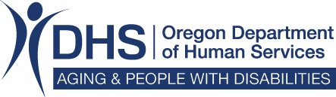 | Long Term Care Capital Improvement & Emergency Preparedness Program  Prior Authorization Form  PHASE Four

Oregon Administrative Rule 411-062 defines the requirements for reimbursement under the Long Term Care Capital Improvement and Emergency Preparedness Program. The Department will accept prior authorization requests for Phase Four projects from May 1, 2022 through October 31, 2022.

Facilities eligible during Phase Four include nursing facilities, assisted living facilities and residential care facilities. Maximum reimbursement for Phase Four projects is $20,000.00.

Phase Four projects include infectious disease prevention, room configuration strategies, and technology and telehealth such as electronic or virtual means or that improve resident socialization and allow for the provision of virtual health care

Fill out the form completely. Attach any relevant documentation, such as a contractor’s bid. Email completed form to: LTC.Improvement@dhsoha.state.or.us.

Facility Name: |  |  |  |  | EIN:
Facility Address: |  | City, State, Zip:
Facility Contact: |  |  |  |  | Contact Phone:
Contact Email: |  |  |  | Medicaid Number:
Year Facility was Built : |  |  | Year of Remodel (if applicable):
Licensed Bed Capacity: | Were you enrolled as a Medicaid provider on 06/30/2021
Requested Grant Amount:
Provide a description of the project:

Provide a description of how this work will promote the well-being and health of your residents by increasing infection control, room configurations, improving resident socialization, or the resident’s ability to access virtual health care.

Provide any other information the Department should consider in evaluating this request.

Submit this form and any supplemental documentation to: LTC.Improvement@dhsoha.state.or.us.
DHS/APD Use Only
Date Received:
Requested amount:
Reviewed by:
Approved?
Amount Authorized:
Date Facility Notified:

